Wise Words - Goodbye 2001!
Gary Wise
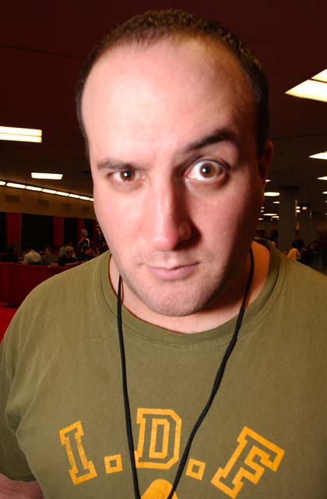
Thanks to September 11, I doubt that 2001 was the best of times for too many people. I for one am looking forward to 2002 as the first year I'll start outside of Canada, as a time for change and potential prosperity, and can only wish the same for the rest of the Magic community. Happy New Year, guys and gals: hope this one is a good one.
I've made a few New Year's resolutions I'd like to share with you for a moment:
1) Renew my efforts as writer and player
2) Keep any personal feuds out of my public writings
3) Write a book about Pro Tour history
I don't know what kind of a market there is out there for this kind of thing, but frankly it doesn't matter: It's something I've wanted to do for some time. Maybe it's the baseball fan in me, but I've always had a deep appreciation for sports history, reading the exploits of the greats of yesteryear, seeing the numbers that represented their performances, listening to those who were there describe their style... their flare. Maybe it's a foolish, romantic notion, but I firmly believe that only in the context of history can we truly appreciate the present events going on around us. If that means remembering the bad with the good, so be it. I want to remember it all.
One of the benefits of having an overbearing personality is that letting people know how you feel about issues and ideas comes with the territory, and I like to think I've done so with regards to those feelings about historical context for those of you still reading Wise Words. With that in tow, you'll understand why this week we look back at the Pro Tour's best moments and successes of 2001. As a bonus, I'll throw in a few predictions for the coming year: maybe someone will drag them out and show you all how wrong I was 365 days from now.

The Best Player
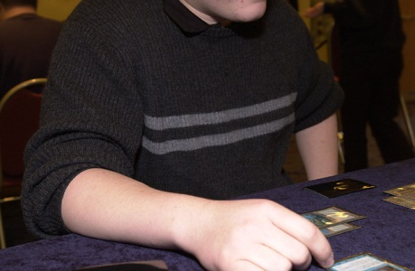
Many people believe Kai's powers come from his magic sweater.
There can be no doubt that Kai Budde has emerged as the best player in the world, and the general consensus says he's attained the status afforded only to 'the best there ever was'. Kai did it all this year, entering 2001 as the defending Pro Tour champion, staying in contention for PT-LA's Top 8 until losing to Kyle Rose in the final draft, putting in money performances in Tokyo and Toronto, winning Barcelona, winning PT-NY as part of Pheonix Foundation, winning GP-London, winning the Invitational and finally, winning the last Pro Tour of the year in New Orleans. That, ladies and gentlemen, is a lot of winning for anyone in a game some people still say comes down to luck. I think it's the ultimate proof that it really doesn't.
In rewriting the record book, Kai has changed the standard by which all future champions will be judged in our game. Having five Pro Tour wins when the next best total is two is just ludicrous, and that he won four of them in a twelve month span redefines Magic itself. For years, Wizards of the Coast has been telling us that Magic is an intellectual sport rather than a mere game. If there's anything out there that proves them right, it's Kai. It should be fun to see if he can keep it up in 2002.

Best Moment
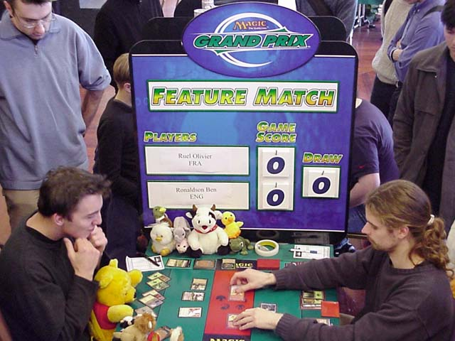
Ruel receives some beats from Ronaldson, his Patriarch lurking at the bottom of his deck.
For me, this had to be at table two of the second Rochester at GP-Biarritz. Midway through the third pack, Ben Ronaldson, firmly entrenched in blue-red and passing to the white-green-black Olivier Ruel, opened up one of the true bombs of the set, Cabal Patriarch, whose triple black casting cost obviously prohibited the Englishman from playing it in his deck. Ruel stood up, raised his arms in triumph and then immediately reached into his backpack, pulled out a disposable camera and handed it to Carlos Berrado, who was sitting on his left. After Ronaldson picked, Olivier leaned over to Ben, hugged him and picked the Patriarch, posing with a big grin on his face as the Spaniard took the picture. The Patriarch helped the Frenchman into the Top 8. Even to the pros, Magic is a game and can be a lot of fun. Olivier wore a kimono on day 1.

Best Emergence
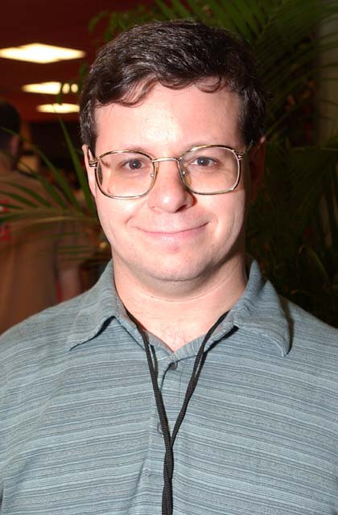
Mikey P, from Brooklyn, New York, had a red letter year.
While Kai was undoubtedly the best player, Mike Pustilnik had a season to remember. Before 2001, Mikey P was that nice guy who played at Neutral Ground and fluked out a Grand Prix once upon a time. A nicer guy you'd never meet, but his Magic play, while respectable, wasn't seeing him held in the same esteem as some of his peers.
Fresh off a Top 8 performance in Chicago at the end of 2000, Mike shocked the world with his defeat of Kamiel Cornelissen in the finals of the first Pro Tour of the year and what will likely be the last to be held on Magic's equivalent of Wrigley Field (A 90 year old baseball stadium, for those of you not familiar), the Queen Mary. Mike's unusual draft style, which saw him run a mana base of six islands, six swamps and six plains in the Top 8, immediately became synonymous with his name, and if LA were his only success in 2001, that might have been on his tombstone, but LA was only the beginning.
After finishing third in the Player of the Year race, Doctor P went to New Orleans having slowed down a little, but then lightning struck again. Mike won his first two rounds in the Masters and then drafted an obscene red-green deck that allowed him to trounce Chris Benafel in the finals. He then capped off his year with a win at the most anticipated American Grand Prix of the year, Vegas.
Not only is Mike the only player in Pro Tour history to have wins in a Grand Prix, Pro Tour and Masters, but he accomplished the feat in 2001 alone, capturing the World Championship of the game Titan in the process. Not too shabby. I'll wish him a happy New Year, but I think that if he had his druthers, he'd let 2001 go just a little longer.

Best Judge
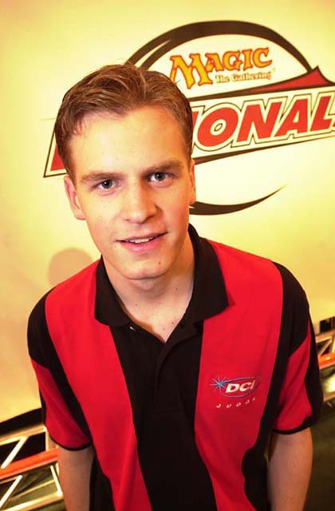
The next time you see Collin Jackson, shoot him... a smile!
With judging improving all the time, the competition here continues to escalate, but with all due respect to James Lee's three hour JSS lectures, Mike Guptil's friendly demeanor and the firm but fair approach to judging of Mike Donais, the man who will be best remembered for his contributions to the changing of the face of the game in 2001 has to be The Sheriff.
At just eighteen years of age, Collin Jackson asserted himself as a source of fear for cheaters everywhere this summer when he spearheaded what appeared to many to be a concerted effort by the DCI to crack down on cheating. Heading into U.S. Nationals, there hadn't been a major suspension for some time, but in that one tournament, Casey McCarrell was caught stacking his deck in the Top 8, Chris Benafel received a game loss from Jackson, his long time friend from the Wizards of the Coast Game Center in Washington. Pete Leiher's perceived attempts at stalling were thwarted by Sheriff Jackson's decision to increase the penalty for slow play awarded, causing Leiher to lose to Brian Hegstad.
The events at U.S. Nationals were merely a precursor to a half year that saw more high profile punishments than the previous three years combined. Three players were disqualified from the Top 8 of APAC Championships, Dave Williams was suspended for stacking his deck at World Championships, Theron Martin suspended for infractions involving tournament fixing and Trey Van Cleave exited the scene at New Orleans thanks to his attempted bribe of Mike Sigrist.
Jackson, now attending Yale, has taken something of a diminished role in the game, though he still attends Pro Tours when his studies allow. One thing is for certain: if the pattern established by the judges of the Pro Tour in 2001 holds firm, soon cheating on the Pro Tour will be reduced to next to nothing.

Best National Emergence

For years, I looked forward to playing against those Japanese pros who were good enough to make it to the Pro Tour. They were courteous, honorable game lovers who I knew I would likely beat, so when I sat down, I knew I had reason to feel confident. That's all in the past now.
This year saw Japanese players emerge, making their first Pro Tour Top 8 and first Masters final while also managing to take their first major individual award. 27 year old Tsoyoshi Fujita of Osaka, en route to the Invitational, made Japan's first Top 8 on home soil, surviving all the way to the final before finally losing to Zvi Mowshowitz in the finals. That same weekend, Panzer Hunters, headed by Pro Tour mainstay Itaru Ishida, made the finals of the Masters before losing to AlphaBetaUnlimited.com. That was really only the beginning.
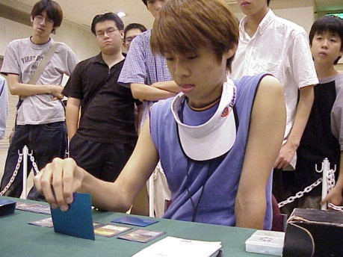
Mori, one of Japan's finest players, is probably best described as 'frenetic.'
By the end of the 2000-2001 season, Katsuhiro Mori had leapt past the competition to capture the Rookie of the Year award, but while his achievements were impressive, it was the way he played the game that made him exciting. Due to language barriers, Japanese players have always come off as quiet and polite, but with Mori you got the sense that there was an attitude behind the exterior, and that attitude came through in vibrant color in the way he played the game: fast.
Never before has the Pro Tour seen a player go through the physical motions of playing the game the way Katsuhiro does, moving head, arms, hands and fingers at blinding speed while often perched or crouched on his chair. If Mori ever times out, it's likely because his opponent has eaten up forty-five minutes of their hour long round, and it's a lot of fun for the spectator to watch someone play the game with that intensity, and understand that Mori's brain is moving at the same rate.
Led by the new guard of Mori and Fujita and the old guard of Ishida, Satoshi Nakamura, Kenichi Fujita, Koichiro Maki and the like, Japan has blossomed in the new millennium, reaching previously uncharted territory. 2002 could be an important year for Asia's most dominant Magic nation.

Best Play
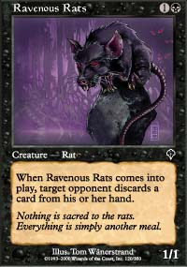
In terms of the mechanics of the game, I doubt there will be any moment from 2001 that will be better remembered than Mike Pustilnik's $30,000 Ravenous Rat. Playing Kamiel Cornelissen in the final game of PT-LA, Mikey P sat staring at Kamiel's five lands and one card in hand and cast the 1/1 Ravenous Rats, forcing the Dutch rookie to discard.
Cornelissen put the last card in his hand into the graveyard, revealing Rith, the Awakener, the best card in Kamiel's deck and at that point in the match an obvious game breaker. Mikey P, upon seeing the discarded dragon legend, muttered "best rat ever", causing the crowd to go wild. In the end, that Rat made all the difference, propelling the Brooklyn native to the championship and eternal supremacy of the Queen Mary.

Predictions
Here are a few of the things I see happening over the next calendar year:
- Kai Budde will win a Pro Tour.
- Katshiro Mori will make his first Top 8, and he won't be the only Japanese player to play in the Pro Tour on a Sunday.
- Scott Johns will have a son, and the kid will have to wait until 2016 to make his first Top 8.
- Chris Ronaldson, Ben's father, will qualify for a Pro Tour.
- Kamiel Cornelissen's consecutive money finishes streak will be broken.
- John Rizzo will retire from writing, electing to join a convent from which he'll be rejected for referring to all the nuns as 'Becky'.
- Sol Malka will solicit votes for the 2002 CCGPrime.com War of the Internet writers claiming to be a casual gamer despite attending every Pro Tour and American Grand Prix of the year.
- A StarCityGames.com writer will win the aforementioned war.
- Jamie Wakefield will not return to the game (sorry folks).
- Pro Tour-San Diego will make players realize the Boat was an overpriced, over-romanticized novelty and the game will create its own institutions.
- We'll all have great years, regardless of Pro Tour finishes.
Have a great 2002. See you next week.

